assignment 3

Submitted by Mohammad Tayyab Alam 24157

Institute of Business Administration Karachi

Financial Data Analytics by Sir Vishal

# Question 1.)

## What features did you create and what is the intuitions and how the model evaluation changed when you added new features. Compare and contrast. (Tip: run file without features and then re-run after adding features). **20 marks**

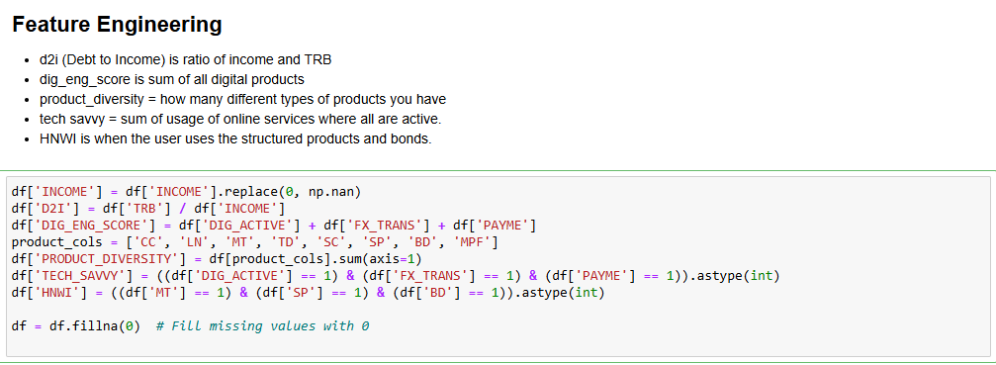

**Answer)**

In my analysis, I developed several features to better capture customer behaviors. D2I (Debt-to-Income Ratio) was created to measure financial leverage by dividing Total Relationship Balance (TRB) by Income. DIG_ENG_SCORE was designed to gauge digital engagement by summing activities like DIG_ACTIVE, FX_TRANS, and PAYME. TECH_SAVVY flags customers who actively use multiple digital services, showing their comfort with technology. HNWI flags high-net-worth individuals, identified by using premium products like mortgages and bonds. Age categories were also created to identify individuals of different age groups as age and life events correspond to spending and saving habits. For instance, someone in their 20s may have low savings but be highly digitally active, using online payments for things like university expenses.

These features enhanced the model's ability to segment customers effectively. After incorporating them, the silhouette score improved from 0.178 (raw data) to 0.686 at K=5, indicating better-defined clusters and more accurate customer segmentation.

# Question 2.)

## How can customer segmentation (via K-Means) help HSBC enhance its Customer Life Cycle Management (CLCM) strategy? (Only answer based on your findings through the code you ran or else you will get no credit for a generic answer.) **10 marks**

**Answer)**

1. **Cluster 0 (Students – Acquisition Phase)**:

* **INCOME**: 25,184 (Low income)
* **TRB**: 68,380 (Moderate transaction behavior)
* **D2I**: 6.68 (High debt-to-income ratio)
* **DIG_ENG_SCORE**: 1.51 (Moderate engagement)
* **Cheap loans and digital products to address customer Activation of CLCM. Use in person employees to address the moderate engagement.**

1. **Cluster 1 (Affluent Professionals)**:

* **INCOME**: 33,282 (High income)
* **TRB**: 212,943 (High transaction behavior)
* **D2I**: 8.39 (High debt-to-income ratio)
* **DIG_ENG_SCORE**: 1.46 (Moderate engagement)
* **Relationship deepening phase**
* **Manage the default risk by offering financial planning and advice to retain customers.**

1. **Cluster 2 (Mid-Level Professionals)**:

* **INCOME**: 29,998 (Mid income)
* **TRB**: 153,498 (Moderate transaction behavior)
* **D2I**: 5.40 (Moderate debt-to-income ratio)
* **DIG_ENG_SCORE**: 1.51 (Moderate engagement)
* **Relationship deepening phase**
* **Introduce mobile first banking services to deepen relationship and extend customer life by engaging in person to address to low digital engagement.**

1. **Cluster 3 (Financially Stable Professionals):**

* **INCOME**: 39,799 (Higher income)
* **TRB**: 177,477 (Moderate transaction behavior)
* **D2I**: 4.56 (Low debt-to-income ratio)
* **DIG_ENG_SCORE**: 2.00 (High engagement)
* **Relationship deepening phase**
* **Offer the opportunity to invest in private equity digitally. Offer investment opportunities via application.**

1. **Cluster 4 (High Income, High Debt, Very High Digital Engagement):**

* **INCOME**: 38,809 (High income)
* **TRB**: 225,590 (High transaction behavior)
* **D2I**: 8.39 (High debt-to-income ratio)
* **DIG_ENG_SCORE**: 3.00 (Very high engagement)
* **Relationship deepening phase**
* **Offer wealth and debt management solutions via robo advisers and in app support.**

# Question 3.)

## What are the key differences between top-down and bottom-up market segmentation?

## (Answer based on the clustering results of your code) **15 marks**

Figure 2 Bottom Up Segmentation

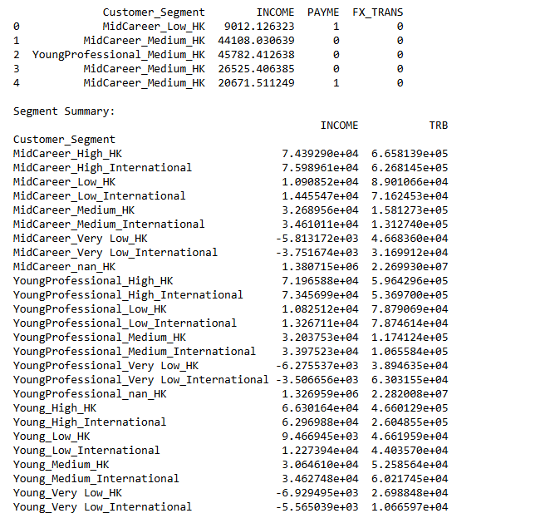

Figure 2 Top Down Segmentation Clusters

**Answer)**

In top down segmentation, we use predefined variables based on demographics such as age groups like Young (18-24), income categories (high low medium) and geographic indicators based on PayME and Fx_Trans for HK and International. From top down, we got general segments like Young_Low_HK meaning that the customer is Young, has low income and did domestic transactions. The most dominant segment was MidCareer_Low_HK that had high average income and TRB meaning that it is an important segment to focus on.

On the other hand, the bottom-up approach takes a more data-driven path, focusing on behavioral traits like Debt-to-Income (D2I), digital engagement scores, tech savviness, and whether a customer is a high-net-worth individual (HNWI) using complex financial products as shown by Cluster 4 and 3. This method captures more detail like digital engagement, which is not captured by general top down segmentation since we do not do behavioral analysis.

# Question 4.)

## If you are working for a Pakistani financial institutions, based on your understanding of the case study and having run the K Means Clustering application via code, what learnings would you replicate at that institution. (Choose the name of the financial intuitions that is alphabetically closer to your first name.) **15 marks**

**Answer)**

In the case study, majority population was young which is similar to Pakistani demographics where the median age is 20.6 years and approximately 50% of the population falls in the Gen-Z and Millennial category. In the assignment, I learned that creating new behavioral features like debt-to-income, digital engagement scores and HNWI who used structured products and were tech savvy resulted in improved clustering accuracy and outperformed the top down segmentation. This shows the importance of financial activity and digital engagement in the context of young customers.

Therefore, since Pakistani demographics are similar I would use such clustering at UBL Bank limited to offer personalized wealth management to HNWI’s and place more emphasis on creating awareness of digital products such as UBL mobile banking app and the easy account for university students. This will help in acquiring more young customers and ensure that the millennials with different incomes are catered to.